Mason, Phil
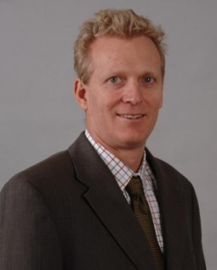
Phil has a Bachelor in Science - Forestry from the Australian National University and an MBA from the University of Western Australia.
Manager, Operations, New Forests Australia, is an experienced forester who leads the operational management of New Forests' Australian assets. Before joining New Forests, Phil worked for several large forestry companies including Elders Forestry (Integrated Tree Cropping), Fletcher Challenge (Norske Skog) and State Forests of New South Wales. He has also worked for URS Australia and Jaakko Poyry, where he conducted consulting assignments throughout Australia, the Pacific, Asia and South Africa. He is based in Melbourne.

